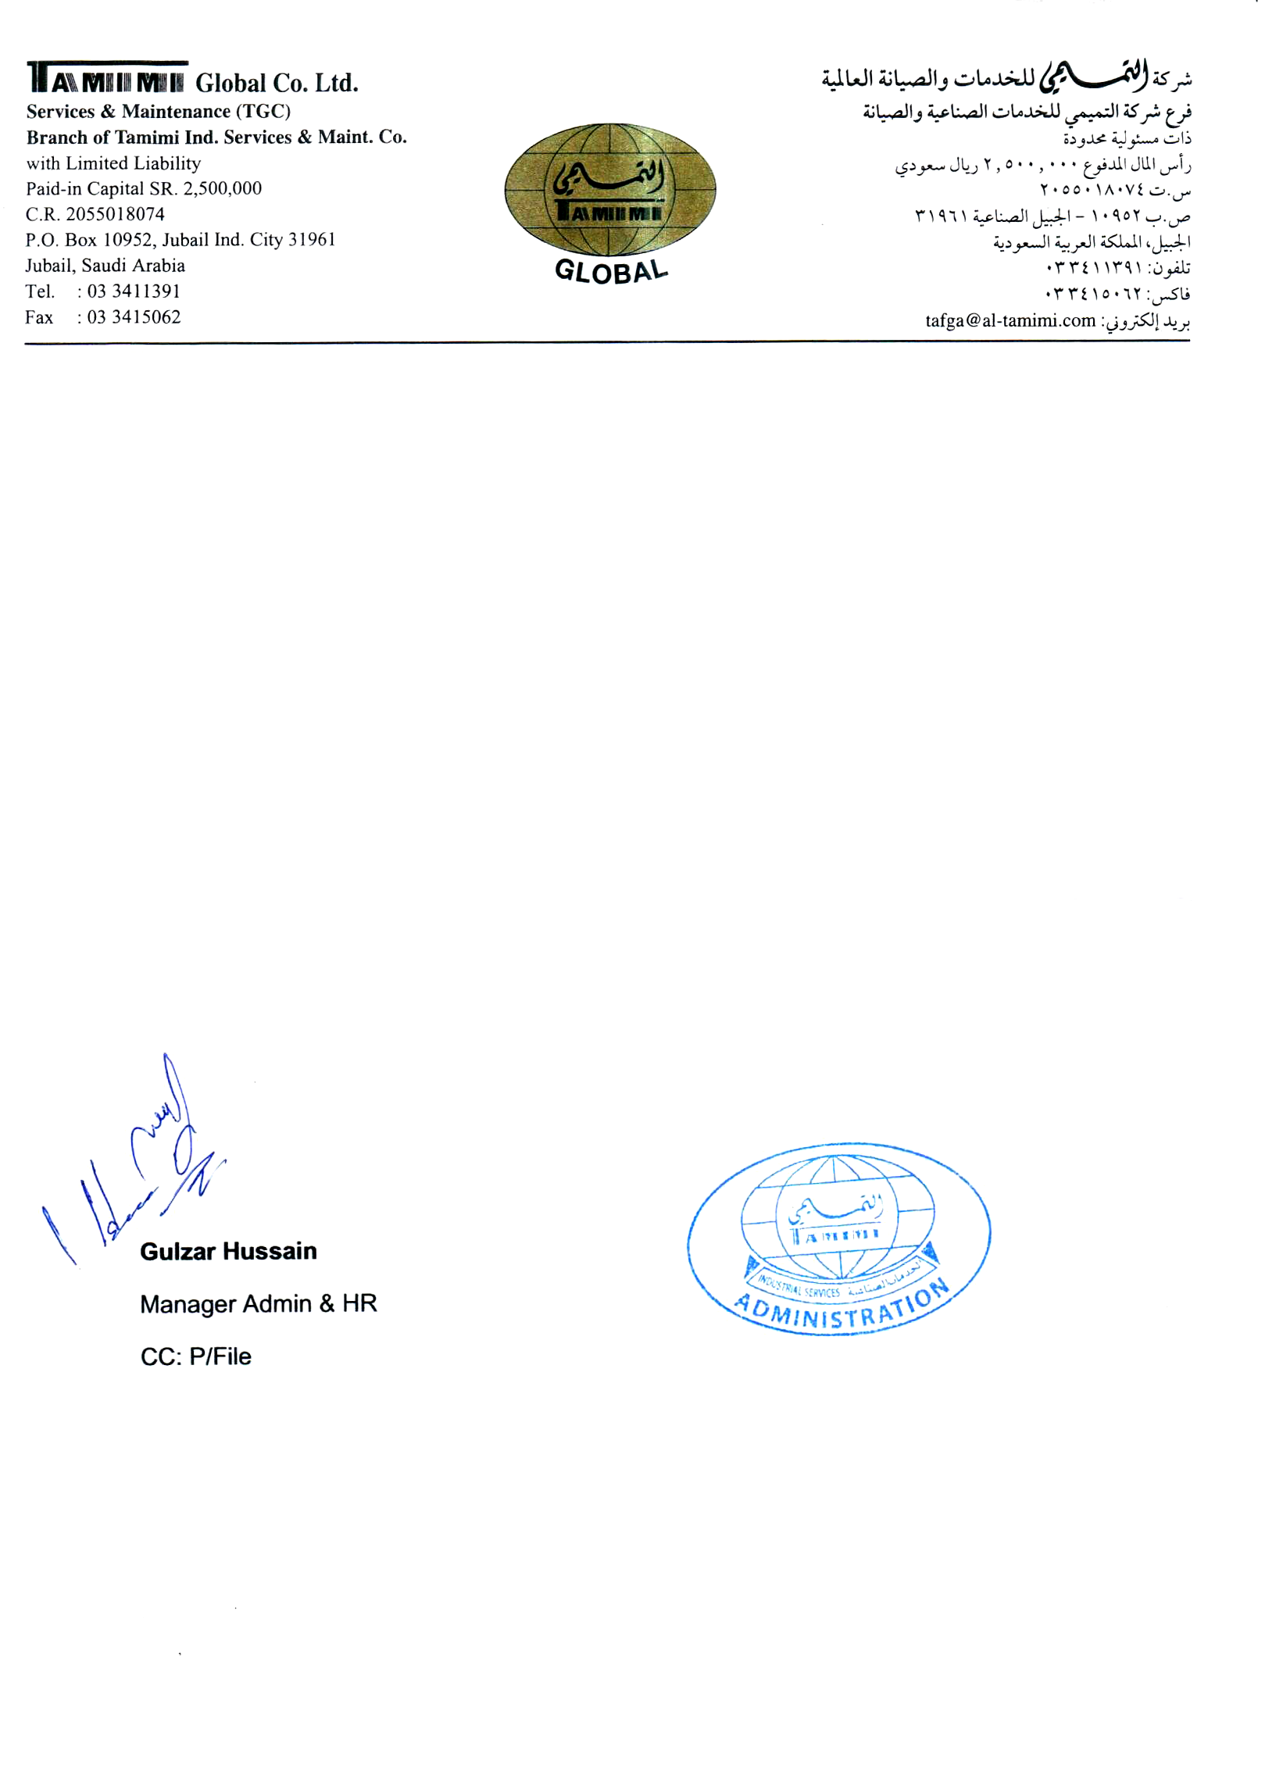

No. HRD/PF-412958

Dated: <To>

**TO WHOM IT MAY CONCERN**

This is to certify that Mr. <Name> S/O <fname> a Pakistani National having Passport # <Passport> has worked with this Organization as a <Designation> from <From> to <To>.

During the period of his employment with the company his performance, throughout this tenure was satisfactory and we found him to be a dedicated member of our Organization.

We wish him all the success in his future endeavors